UNIVERSIDAD AUTÓNOMA DE CHIAPAS

FACULTAD DE CONTADURÍA Y ADMINISTRACIÓN, CAMPUS I

LICENCIATURA EN INGENIERÍA EN DESARROLLO Y TECNOLOGÍAS DE SOFTWARE

CONMUTADORES Y REDES INALÁMBRICAS

SEMESTRE: 7° GRUPO: “M”

DR. LUIS GUTIÉRREZ ALFARO

ALUMNO: DANIEL ALBERTO PÉREZ ALCÁZAR

ACT. 3.1 CONFIGURA UN VTP CON VLANS EN PACKET TRACERT

Jueves 03 de octubre de 2024.

Tuxtla Gutiérrez, Chiapas.

**Evidencias:**

Link a la actividad en GitHub:

<https://github.com/Daniel-Alcazar/Conmutadores-Y-Redes-Inal-mbricas.git>

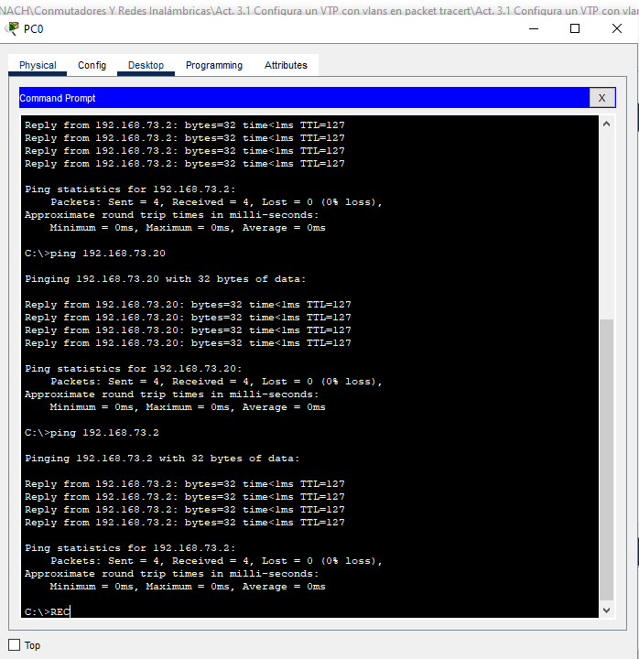PC0: 192.168.72.2

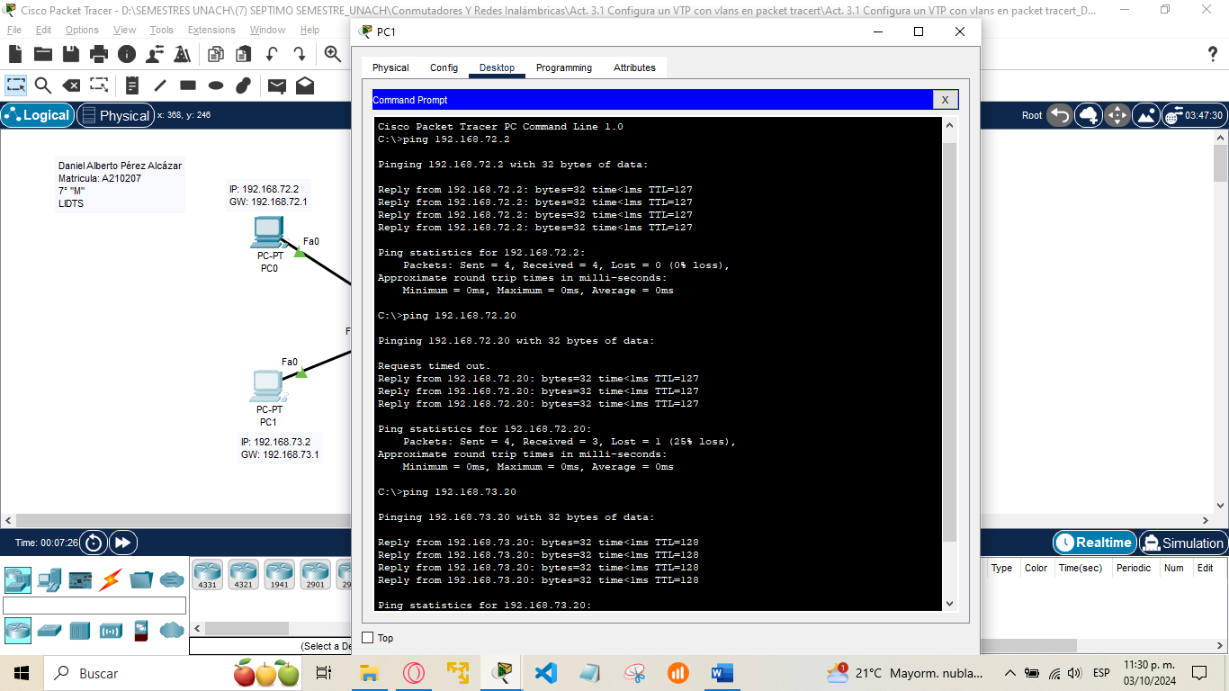PC1: 192.168.73.2

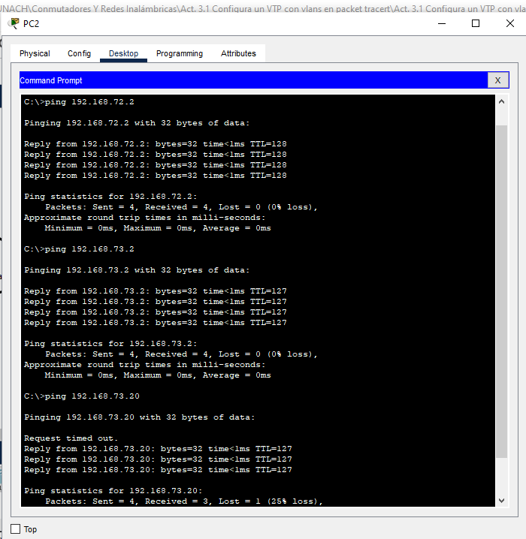PC2: 192.168.72.20

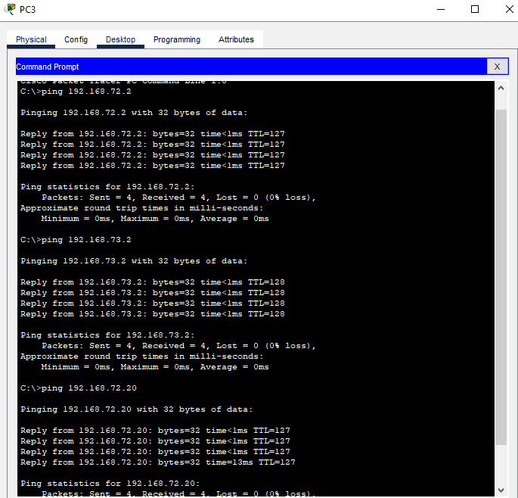PC3: 192.168.73.20

**Configuraciones:**

Daniel Alberto Pérez Alcázar 7° "M"

---------------------------------------------Switch1_DAPA---------------------------------------------

Switch>ena

Switch#conf t

Enter configuration commands, one per line. End with CNTL/Z.

Switch(config)#hostname Switch1_DAPA

Switch1_DAPA(config)#vlan 50

Switch1_DAPA(config-vlan)#name LIDTS-VTP

Switch1_DAPA(config-vlan)#exit

Switch1_DAPA(config)#

---------------------------------------------Switch0_DAPA---------------------------------------------

Switch>ena

Switch#conf t

Enter configuration commands, one per line. End with CNTL/Z.

Switch(config)#hostname Switch0_DAPA

Switch0_DAPA(config)#interface fastEthernet 0/24

Switch0_DAPA(config-if)#switchport mode trunk

Switch0_DAPA(config-if)#

%LINEPROTO-5-UPDOWN: Line protocol on Interface FastEthernet0/24, changed state to down

%LINEPROTO-5-UPDOWN: Line protocol on Interface FastEthernet0/24, changed state to up

Switch0_DAPA(config-if)#exit

Switch0_DAPA(config)#

---------------------------------------------Switch1_DAPA---------------------------------------------

Switch1_DAPA(config)#vtp mode client

Setting device to VTP CLIENT mode.

Switch1_DAPA(config)#vtp domain UNACH

Changing VTP domain name from NULL to UNACH

Switch1_DAPA(config)#exit

Switch1_DAPA#conf t

Enter configuration commands, one per line. End with CNTL/Z.

Switch1_DAPA(config)#vlan 20

VTP VLAN configuration not allowed when device is in CLIENT mode.

Switch1_DAPA(config)#

---------------------------------------------Switch0_DAPA---------------------------------------------

Switch0_DAPA(config)#vtp mode server

Device mode already VTP SERVER.

Switch0_DAPA(config)#vtp domain UNACH

Domain name already set to UNACH.

Switch0_DAPA(config)#exit

Switch0_DAPA(config)#vlan 10

Switch0_DAPA(config-vlan)#name SISTEMAS

Switch0_DAPA(config-vlan)#exit

Switch0_DAPA(config)#vlan 20

Switch0_DAPA(config-vlan)#name SOFTWARE

Switch0_DAPA(config-vlan)#exit

Switch0_DAPA(config)#vlan 30

Switch0_DAPA(config-vlan)#name COMPUTO

Switch0_DAPA(config-vlan)#exit

Switch0_DAPA(config)#exit

Switch0_DAPA#

%SYS-5-CONFIG_I: Configured from console by console

Switch0_DAPA#wr

---------------------------------------------Switch0_DAPA---------------------------------------------

Switch0_DAPA(config)#interface fastEthernet 0/10

Switch0_DAPA(config-if)#switchport access vlan 10

Switch0_DAPA(config-if)#exit

Switch0_DAPA(config)#interface fastEthernet 0/11

Switch0_DAPA(config-if)#switchport access vlan 20

Switch0_DAPA(config-if)#exit

Switch0_DAPA(config)#interface fastEthernet 0/12

Switch0_DAPA(config-if)#switchport access vlan 30

Switch0_DAPA(config-if)#exit

---------------------------------------------Switch1_DAPA---------------------------------------------

Switch1_DAPA(config)#interface fastEthernet 0/10

Switch1_DAPA(config-if)#switchport access vlan 10

Switch1_DAPA(config-if)#exit

Switch1_DAPA(config)#interface fastEthernet 0/11

Switch1_DAPA(config-if)#switchport access vlan 20

Switch1_DAPA(config-if)#exit

Switch1_DAPA(config)#interface fastEthernet 0/12

Switch1_DAPA(config-if)#switchport access vlan 30

Switch1_DAPA(config-if)#exit

Switch1_DAPA(config)#exit

---------------------------------------------Switch0_DAPA---------------------------------------------

Enter configuration commands, one per line. End with CNTL/Z.

Switch0_DAPA(config)#interface fastEthernet 0/1

Switch0_DAPA(config-if)#switchport mode trunk

Switch0_DAPA(config-if)#exit

Switch0_DAPA(config)#exit

---------------------------------------------Router0_DAPA---------------------------------------------

Router>ena

Router#conf t

Enter configuration commands, one per line. End with CNTL/Z.

Router(config)#hostname Router0_DAPA

Router0_DAPA(config)#interface fastEthernet 0/0

Router0_DAPA(config-if)#no sh

Router0_DAPA(config-if)#

%LINK-5-CHANGED: Interface FastEthernet0/0, changed state to up

%LINEPROTO-5-UPDOWN: Line protocol on Interface FastEthernet0/0, changed state to up

Router0_DAPA(config-if)#exit

Router0_DAPA(config)#interface fastEthernet 0/0.10

Router0_DAPA(config-subif)#

%LINK-5-CHANGED: Interface FastEthernet0/0.10, changed state to up

%LINEPROTO-5-UPDOWN: Line protocol on Interface FastEthernet0/0.10, changed state to up

Router0_DAPA(config-subif)#encapsulation dot1q 10

Router0_DAPA(config-subif)#ip address 192.168.72.1 255.255.255.0

Router0_DAPA(config-subif)#exit

Router0_DAPA(config)#interface fastEthernet 0/0.20

Router0_DAPA(config-subif)#

%LINK-5-CHANGED: Interface FastEthernet0/0.20, changed state to up

%LINEPROTO-5-UPDOWN: Line protocol on Interface FastEthernet0/0.20, changed state to up

Router0_DAPA(config-subif)#encapsulation dot1q 20

Router0_DAPA(config-subif)#ip address 192.168.73.1 255.255.255.0

Router0_DAPA(config-subif)#exit

Router0_DAPA(config)#interface fastEthernet 0/0.30

Router0_DAPA(config-subif)#

%LINK-5-CHANGED: Interface FastEthernet0/0.30, changed state to up

%LINEPROTO-5-UPDOWN: Line protocol on Interface FastEthernet0/0.30, changed state to up

Router0_DAPA(config-subif)#encapsulation dot1q 30

Router0_DAPA(config-subif)#ip address 192.168.74.1 255.255.255.0

Router0_DAPA(config-subif)#exit

Router0_DAPA(config)#exit

Router0_DAPA#

%SYS-5-CONFIG_I: Configured from console by console

Router0_DAPA#wr

Building configuration...

[OK]

Router0_DAPA#